**Multispecies model estimates of time-varying natural mortality of groundfish in the Gulf of Alaska**

*Grant Adams1, Kirstin Holsman2, Kerim Aydin2, Steve Barbeaux2, Martin Dorn2, Anne Hollowed2, Jim Ianelli2, André Punt1, Ingrid Spies2*, *Ian Stewart3*

[adamsgd@uw.edu](mailto:adamsgd@uw.edu)

*1*School of Aquatic and Fishery Sciences, University of Washington, Seattle, WA 98195, USA

*2*Alaska Fisheries Science Center, NOAA, Seattle, WA 98115, USA

3International Pacific Halibut Commission, Seattle, WA, 98199, USA

**Summary statement**

The climate-enhanced multispecies model (CEATTLE) for the Gulf of Alaska (GOA) estimates that age-1 pollock, Pacific cod, and arrowtooth flounder total natural mortality has declined in recent years and is below the long-term mean. Similarly, estimates of biomass consumed of pollock, Pacific cod, and arrowtooth flounder as prey across all ages is currently below the long term mean, but has increased for pollock.

**Status and trends**

Estimated age-1 total natural mortality (M = M1 + M2) for walleye Pollock, Pacific cod, and arrowtooth flounder peaked between 1990 and 2010. At an average of 1.322 yr*−*1, age-1 M estimated by the model was greatest for pollock and lower for Pacific cod and arrowtooth (females and males), which had averages of 0.373 (arrowtooth females), 0.463 (arrowtooth males), and 0.847 yr*−*1 (Pacific cod). After decreasing in recent years, pollock age-1 M remained slightly lower in 2021 relative to the long-term mean and the values used for single species assessment (age-1 M = 1.39; Fig. 1). Additionally, Pacific cod and arrowtooth flounder age-1 M were below the long-term mean after decreasing in recent years, but above the values used/estimated for the single species assessment of 0.2 (arrowtooth females), 0.35 (arrowtooth males), and 0.50 (Pacific cod) in 2018.

On average 210,821 mt of age-1 pollock, 6,802 mt of age-1 arrowtooth flounder, 3,380 mt of age-1 Pacific cod was consumed annually by species included in the model. Across all ages 1,486,512 mt of walleye pollock, 68,700 mt of arrowtooth flounder, and 12,691 mt of Pacific cod was consumed annually by species included in the model (Figure 3). The total biomass consumed of pollock as prey across all ages increased in 2021 compared to 2020, while the total biomass consumed of arrowtooth flounder and Pacific cod has decreased in recent years. The total biomass consumed of pollock, Pacific cod, and arrowtooth flounder as prey across all ages is currently below the long term mean.

**Factors influencing observed trends**

Temporal patterns in total natural mortality reflect annually varying changes in predation mortality that primarily impact age-1 fish (but also impact older age classes). Predation mortality at age-1 for all species was primarily driven by arrowtooth flounder (Figure 2) and arrowtooth flounder biomass has declined and remained relatively constant in recent years. Arrowtooth flounder was the primary consumer of all prey biomass across ages and species included in the model (Fig. 4). Increases in biomass consumed of walleye Pollock in 2021 relative to 2020 reflect elevated recruitment of age-1 Pollock in 2021 that is available to predators (Figure 5).

**Implications**

We find evidence of continued decline in predation mortality on age-1 pollock, Pacific cod and arrowtooth flounder. Declines in total predator biomass are contributing to an overall decline in total consumption and therefore reduced predation mortality. Between 1990 and 2010, relatively high natural mortality rates reflect patterns in annual demand for prey from arrowtooth flounder, whose biomass peaked during this time period. A strong recruitment of age-1 pollock in 2021 has led to an increase in biomass of pollock being consumed by predators. Decreases in predation mortality in recent years suggest that the disappearance of the large age-1 recruitment of pollock in 2019 was not due wholly to predation by species included in the model (Figure 5).

**Description of index**

We report trends in age-1 total natural mortality for walleye pollock (*Gadus chalcogrammus*), Pacific cod (*Gadus macro- cephalus*) and arrowtooth flounder (*Atheresthes stomias*), from the Gulf of Alaska (GOA). Total natural mortality rates are based on model estimated sex-specific, age-invariant residual mortality (M1) and model estimates of annual predation mortality (M2) from the multi-species statistical catch-at-age assessment model (known as CEATTLE; Climate- Enhanced, Age-based model with Temperature-specific Trophic Linkages and Energetics; Holsman, Ianelli, Aydin, Punt, & Moffitt, 2015). CEATTLE has been modified for the GOA and implemented in Template Model Builder (Kristensen, Nielsen, Berg, Skaug, & Bell, 2015) to allow for the fitting of two-sex models, multiple sources of data, time-varying selectivity, time-varying catchability, and random effects. The model is based, in part, on the parameterization and data used for recent stock assessment models of each species (Barbeaux et al., 2018; Dorn, Aydin, Jones, Palsson, & Spalinger, 2018; Spies & Palsson, 2018). The model is fit to data from five fisheries and seven surveys, including both age and length composition assumed to come from a multinomial distribution and includes inputs of abundance-at-age from recent stock assessment models of Pacific halibut scaled to the proportion of age-5+ biomass in IPHC management area 3 (Stewart & Hicks, 2019). Model estimates of predation mortality are empirically derived by bioenergetics based consumption information and diet data from the GOA to inform predator-prey suitability (Holsman & Aydin, 2015; Holsman, Aydin, Sullivan, Hurst, & Kruse, 2019). The model was fit to data from 1977 to 2021.

**Literature cited**

Barbeaux, S., Aydin, K., Fissel, B., Holsman, K., Laurel, B., & Palsson, W. (2018). Chapter 2 : Assessment of the Pacific cod stock in the Gulf of Alaska, (December).

Dorn, M., Aydin, K., Jones, D., Palsson, W., & Spalinger, K. (2018). Chapter 1: Assessment of the walleye pollock stock in the Gulf of Alaska., (December).

Holsman, K. K., & Aydin, K. (2015). Comparative methods for evaluating climate change impacts on the foraging ecology of Alaskan groundfish. *Marine Ecology Progress Series*, *521*, 217–235. https://doi.org/10.3354/meps11102

Holsman, K. K., Aydin, K., Sullivan, J., Hurst, T., & Kruse, G. H. (2019). Climate effects and bottom-up controls on growth and size-at-age of Pacific halibut (Hippoglossus stenolepis) in Alaska (USA). *Fisheries Oceanography*, *28*(3), 345–358. https://doi.org/10.1111/fog.12416

Holsman, K. K., Ianelli, J., Aydin, K., Punt, A. E., & Moffitt, E. A. (2016). A comparison of fisheries biological reference points estimated from temperature-specific multi-species and single-species climate-enhanced stock assessment models. *Deep Sea Research Part II: Topical Studies in Oceanography*, *134*, 360–378. https://doi.org/10.1016/j.dsr2.2015.08.001

Kristensen, K., Nielsen, A., Berg, C. W., Skaug, H., & Bell, B. (2015). TMB: Automatic Differentiation and Laplace Approximation. *ArXiv*, *70*(5), 1–21. https://doi.org/10.18637/jss.v070.i05

Spies, I., & Palsson, W. (2018). Assessment of the Arrowtooth Flounder Stock in the Gulf of Alaska. *NPFMC Gulf of Alaska Stock Assessment and Fishery Evaluation*, (December 2018), 691–752.

Stewart, I., & Hicks, A. (2019). *Assessment of the Pacific halibut (Hippoglossus stenolepis) stock at the end of 2018*. Seattle, Wa. Retrieved from https://iphc.int/data/projection-tool

**Table 1.** Annual estimates of predation mortality (M2) and total mortality (Z) for age-1 pollock, Pacific cod, and arrowtoth flounder from GOA CEATTLE Model between 1977 and 2021. Residual mortality (M1) for each species and sex was estimated as 0.231 (pollock), 0.317 (arrowtooth females), 0.379 (arrowtooth males), and 0.446 (Pacific cod).

|  |  |  |  |  |  |  |  |  |
| --- | --- | --- | --- | --- | --- | --- | --- | --- |
|  | **Pollock** | | **Arrowtooth females** | | **Arrowtooth males** | | **Pacific cod** | |
| **Year** | **M2** | **Z** | **M2** | **Z** | **M2** | **Z** | **M2** | **Z** |
| 1977 | 0.873 | 1.079 | 0.031 | 0.35 | 0.047 | 0.429 | 0.311 | 0.759 |
| 1978 | 0.836 | 1.038 | 0.031 | 0.35 | 0.047 | 0.429 | 0.298 | 0.742 |
| 1979 | 0.818 | 1.032 | 0.034 | 0.354 | 0.051 | 0.435 | 0.279 | 0.722 |
| 1980 | 0.819 | 1.046 | 0.036 | 0.359 | 0.054 | 0.442 | 0.28 | 0.723 |
| 1981 | 0.945 | 1.192 | 0.042 | 0.37 | 0.064 | 0.459 | 0.325 | 0.77 |
| 1982 | 0.83 | 1.088 | 0.04 | 0.371 | 0.06 | 0.461 | 0.305 | 0.751 |
| 1983 | 0.945 | 1.202 | 0.047 | 0.382 | 0.07 | 0.478 | 0.367 | 0.815 |
| 1984 | 0.912 | 1.162 | 0.046 | 0.381 | 0.069 | 0.477 | 0.369 | 0.816 |
| 1985 | 0.891 | 1.131 | 0.047 | 0.382 | 0.071 | 0.477 | 0.346 | 0.792 |
| 1986 | 0.939 | 1.164 | 0.054 | 0.387 | 0.081 | 0.484 | 0.346 | 0.79 |
| 1987 | 1.107 | 1.325 | 0.055 | 0.389 | 0.083 | 0.488 | 0.38 | 0.821 |
| 1988 | 1.116 | 1.329 | 0.051 | 0.386 | 0.077 | 0.483 | 0.378 | 0.817 |
| 1989 | 1.096 | 1.301 | 0.051 | 0.384 | 0.076 | 0.481 | 0.41 | 0.848 |
| 1990 | 1.122 | 1.319 | 0.048 | 0.381 | 0.072 | 0.476 | 0.443 | 0.878 |
| 1991 | 1.486 | 1.658 | 0.058 | 0.393 | 0.088 | 0.494 | 0.561 | 0.989 |
| 1992 | 1.37 | 1.547 | 0.056 | 0.389 | 0.085 | 0.488 | 0.528 | 0.954 |
| 1993 | 1.392 | 1.561 | 0.056 | 0.389 | 0.085 | 0.488 | 0.553 | 0.977 |
| 1994 | 1.383 | 1.544 | 0.054 | 0.388 | 0.082 | 0.486 | 0.555 | 0.979 |
| 1995 | 1.282 | 1.442 | 0.05 | 0.382 | 0.075 | 0.477 | 0.49 | 0.916 |
| 1996 | 1.329 | 1.471 | 0.051 | 0.382 | 0.076 | 0.478 | 0.506 | 0.928 |
| 1997 | 1.289 | 1.427 | 0.049 | 0.378 | 0.074 | 0.471 | 0.478 | 0.9 |
| 1998 | 1.426 | 1.549 | 0.057 | 0.385 | 0.085 | 0.482 | 0.475 | 0.896 |
| 1999 | 1.272 | 1.4 | 0.052 | 0.379 | 0.079 | 0.472 | 0.414 | 0.839 |
| 2000 | 1.274 | 1.399 | 0.047 | 0.374 | 0.071 | 0.465 | 0.407 | 0.831 |
| 2001 | 1.382 | 1.493 | 0.056 | 0.382 | 0.085 | 0.477 | 0.445 | 0.866 |
| 2002 | 1.367 | 1.474 | 0.043 | 0.367 | 0.064 | 0.455 | 0.479 | 0.894 |
| 2003 | 1.626 | 1.71 | 0.049 | 0.374 | 0.074 | 0.464 | 0.597 | 1.002 |
| 2004 | 1.638 | 1.721 | 0.05 | 0.375 | 0.075 | 0.466 | 0.652 | 1.053 |
| 2005 | 1.65 | 1.732 | 0.054 | 0.378 | 0.081 | 0.472 | 0.683 | 1.082 |
| 2006 | 1.547 | 1.637 | 0.053 | 0.377 | 0.08 | 0.47 | 0.586 | 0.993 |
| 2007 | 1.391 | 1.492 | 0.049 | 0.372 | 0.074 | 0.462 | 0.495 | 0.908 |
| 2008 | 1.323 | 1.429 | 0.044 | 0.367 | 0.066 | 0.454 | 0.458 | 0.872 |
| 2009 | 1.183 | 1.307 | 0.041 | 0.364 | 0.061 | 0.449 | 0.428 | 0.842 |
| 2010 | 1.358 | 1.468 | 0.046 | 0.37 | 0.07 | 0.459 | 0.517 | 0.924 |
| 2011 | 1.177 | 1.306 | 0.042 | 0.366 | 0.062 | 0.453 | 0.446 | 0.86 |
| 2012 | 1.064 | 1.205 | 0.041 | 0.366 | 0.062 | 0.453 | 0.392 | 0.813 |
| 2013 | 0.972 | 1.126 | 0.038 | 0.362 | 0.057 | 0.447 | 0.319 | 0.747 |
| 2014 | 0.868 | 1.037 | 0.035 | 0.359 | 0.052 | 0.442 | 0.279 | 0.713 |
| 2015 | 1.07 | 1.222 | 0.036 | 0.359 | 0.055 | 0.443 | 0.347 | 0.771 |
| 2016 | 1.051 | 1.21 | 0.04 | 0.365 | 0.06 | 0.451 | 0.357 | 0.778 |
| 2017 | 0.978 | 1.136 | 0.039 | 0.365 | 0.059 | 0.451 | 0.356 | 0.777 |
| 2018 | 0.988 | 1.141 | 0.041 | 0.367 | 0.062 | 0.455 | 0.36 | 0.781 |
| 2019 | 0.927 | 1.081 | 0.039 | 0.363 | 0.058 | 0.448 | 0.326 | 0.751 |
| 2020 | 0.948 | 1.098 | 0.035 | 0.358 | 0.053 | 0.441 | 0.332 | 0.756 |
| 2021 | 0.941 | 1.098 | 0.035 | 0.357 | 0.052 | 0.439 | 0.327 | 0.753 |

**Figure 1.** Annual variation in (black line) and average (grey line) total natural mortality (M1 + M2) for age-1 pollock, Pacific cod, and arrowtoth flounder (females and males) estimated from the multi-species GOA CEATTLE model between 1977 and 2021. Note: y-axis differ.

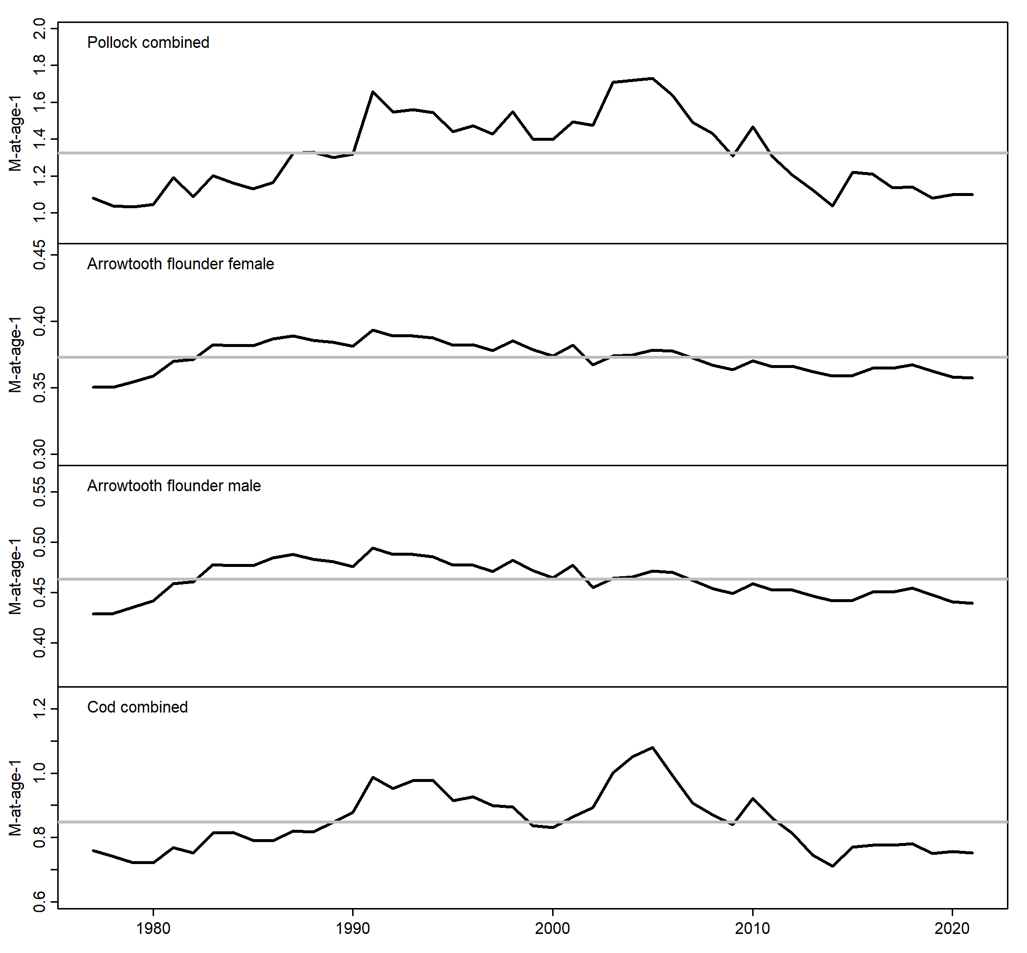

**Figure 2.** Proportion of total age-1 predation mortality (M2) from pollock, Pacific cod, and arrowtoth flounder (females and males) estimated from the multi-species GOA CEATTLE Model between 1977 and 2021.

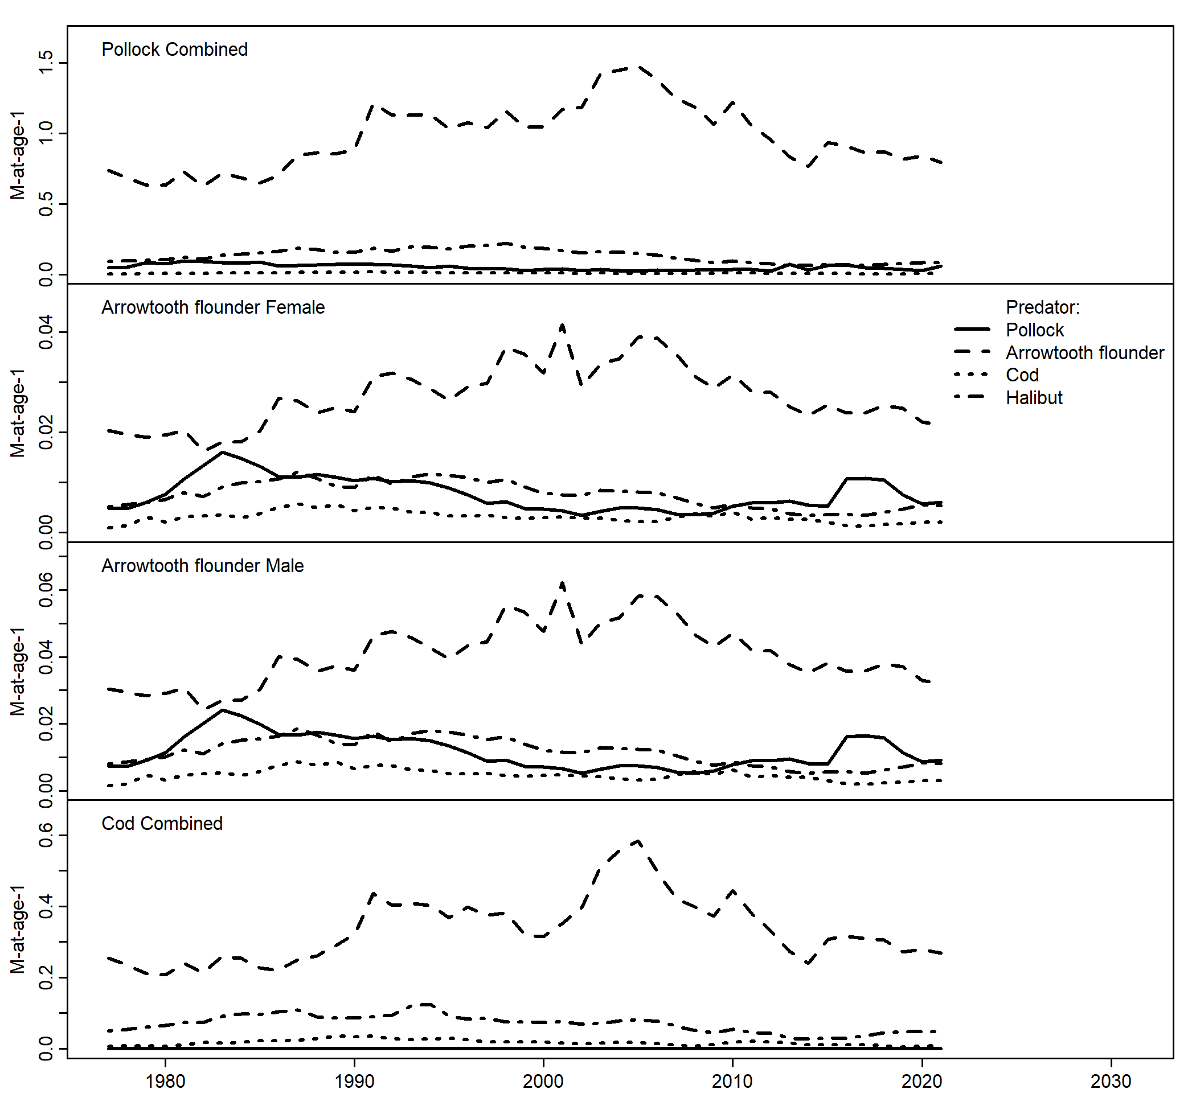

**Figure 3.** Estimates of pollock, Pacific cod, and arrowtoth flounder biomass consumed by all predators from the multi-species GOA CEATTLE model between 1977 and 2021. Gray lines indicate mean estimates for each species across all years.

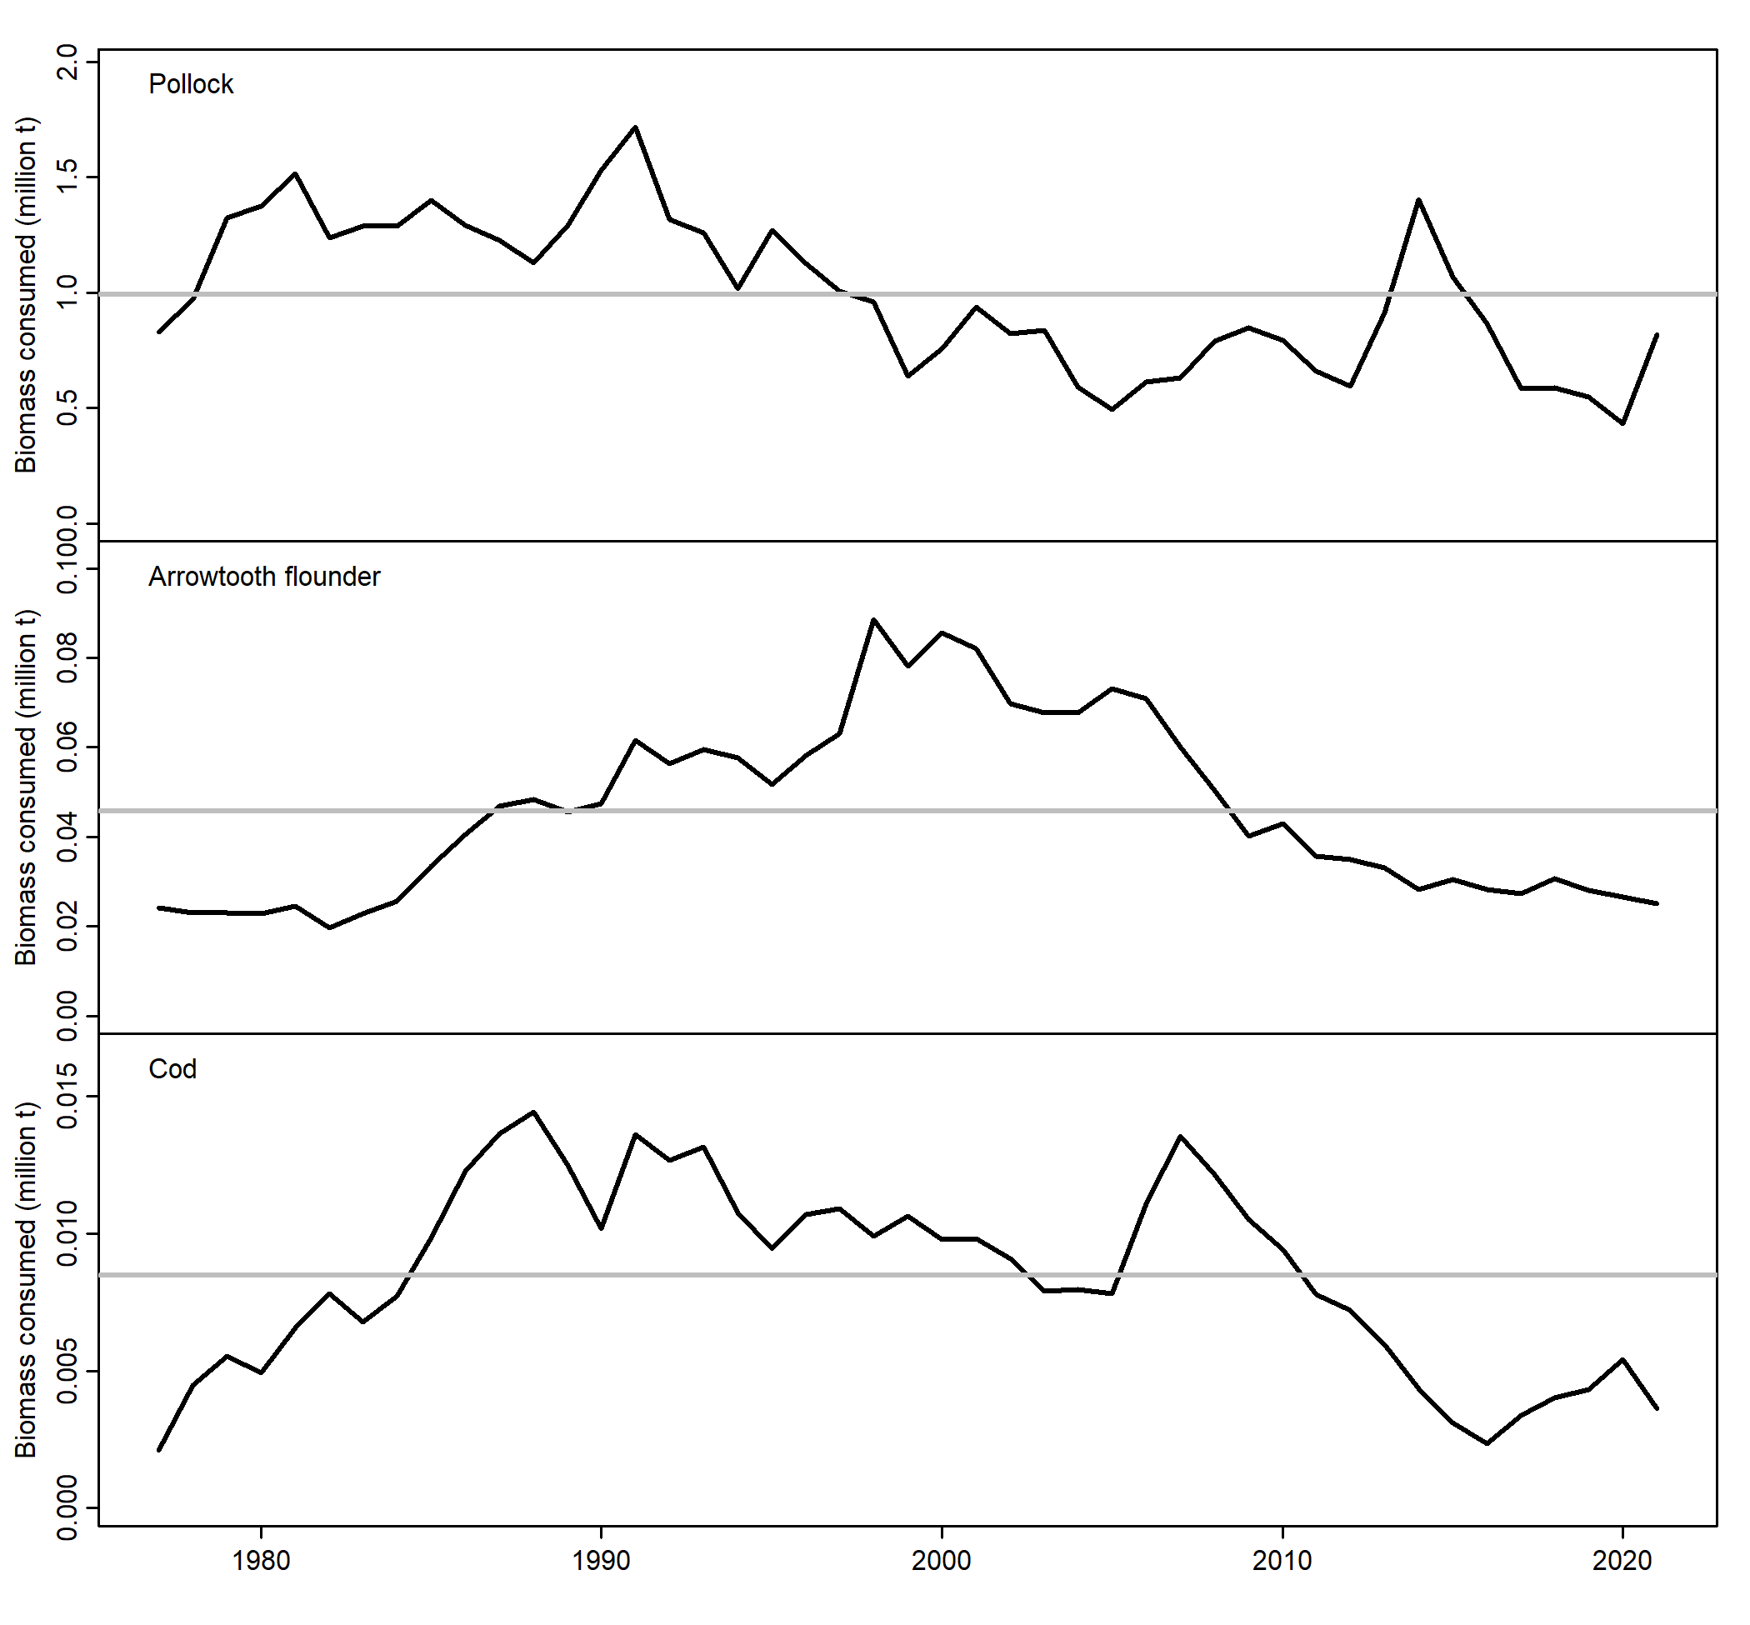

**Figure 4.** Estimates of pollock, Pacific cod, and arrowtoth flounder biomass consumed by predators in the multi-species GOA CEATTLE model between 1977 and 2021.

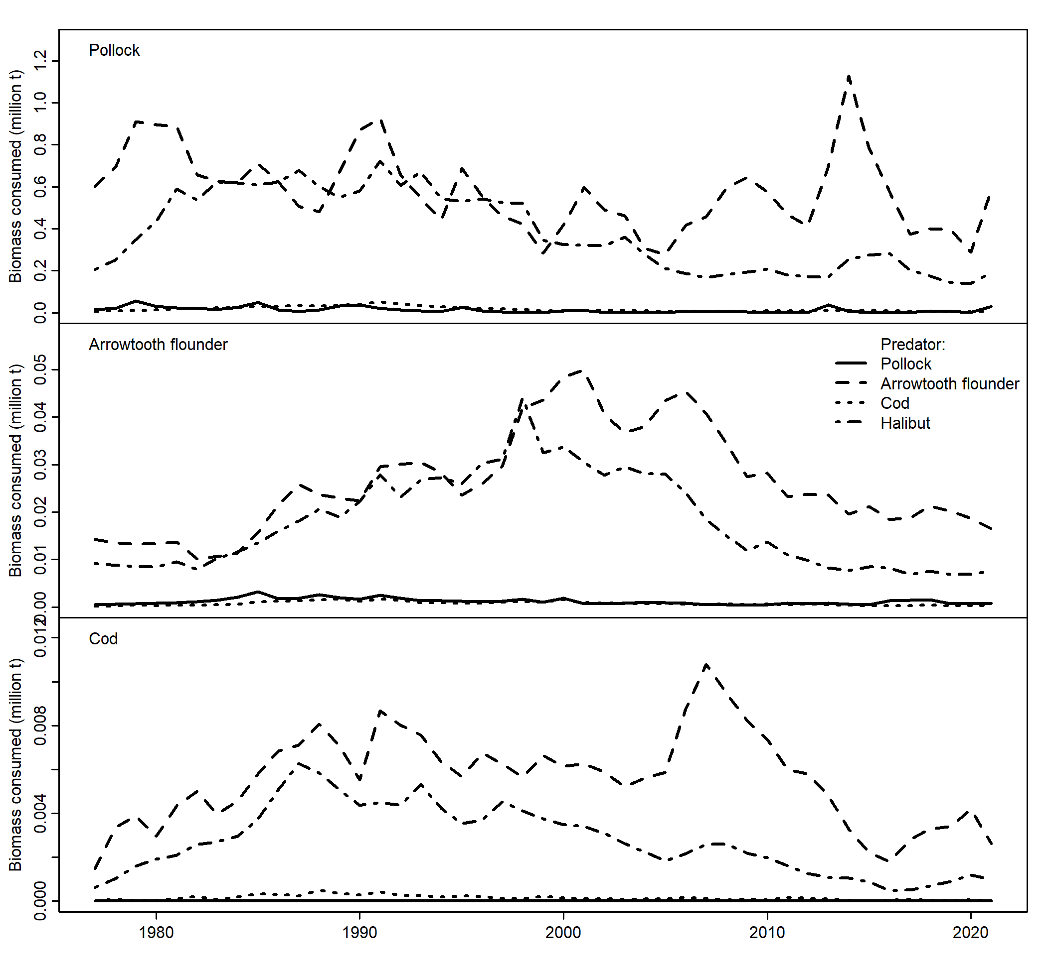

**Figure 5.** Estimates of pollock, Pacific cod, and arrowtoth flounder (ATF) numbers-at-age, total natural mortality-at-age, and biomass consumed as prey by age from predators in the multi-species CEATTLE model between 1977 and 2021.

